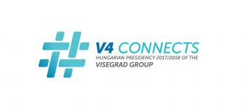
V4 + Georgia Start-ups Event

A unique opportunity to present your business in front of interesting VC investors, angel investors, and business consultants for no cost. Just bring your product, roll-ups and prepare a 3-minute pitch.
We are looking for micro companies from Slovakia (20-25 companies for the whole event) who should provide their business summary as representing material (within 1 page).

Who will attend? Who can you meet?


Enterprise Ireland - government organisation responsible for the development and growth of enterprises,

Dublin Business Innovation Centre - provides business consultancy services to early stage, high potential start-ups,

Halo Business Angel Network - development of business angel syndicates in Ireland,

iCham – supports businesses across Central and Eastern Europe

And other invited VC Investors, angel investors, etc.
Press release.

When?
23rd November 2017

Where?

The Guinness Enterprise Centre
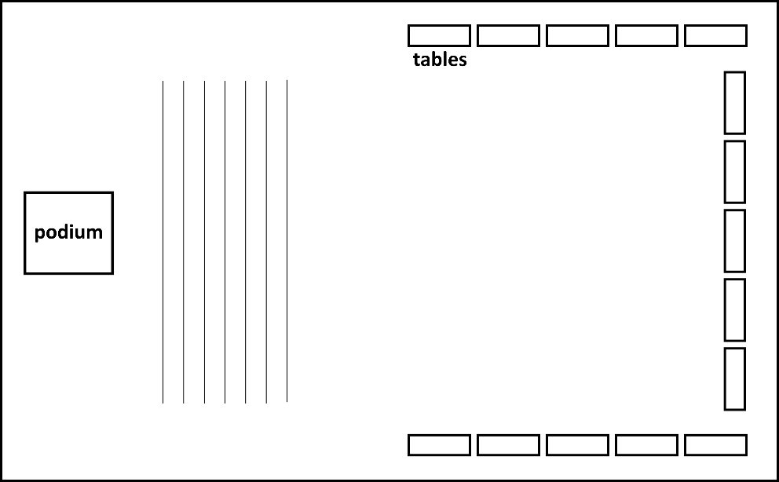

*including small refreshments and drinks typical for V4 countries and Georgia

